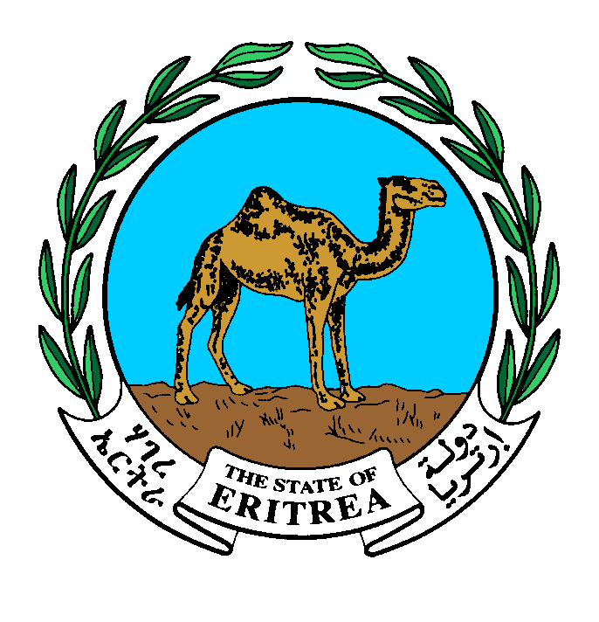
UNDP ERITREA

2015 Annual Work Plan

Project name | Amount
SUSTAINABLE LAND MANAGMENT | US$ 1,434,614.00

Dr. Giorgis Teklemikael  Minister  Ministry of National Development | Ms. Christine N. Umutoni  Resident Representative  UNDP Eritrea | Mr. Tesfai Gebresellasie  Minister  Ministry of Land Water and Environment
Signature: | Signature: | Signature:
Date: | Date: | Date:

Annual Work Plan 2015

Country: Eritrea

SPCF Outcome: Eritrea is on track towards the achievement of MDG targets for environmental sustainability (MDG7)
Expected Outcome (SRF): Support development and protection of the environment and natural resources.

Expected Outcome Indicator: Number of households with improved land use management system and level of increased production
Expected Outputs:
Enabling conditions for sustainable land management established Coordinating Authority: Ministry of National Development

Implementing partners: Ministry of Land, Water and Environment
The proposed project will provide an enabling environment for sustainable land management through four outcomes that overcome the barriers, and are in line with the objectives of the GEF Strategic Investment Program for SLM in Sub-Saharan Africa (SIP) and SPCF 2013-16. These include i) development and testing of SLM models in pilot areas; the Serejeka sub-zoba of the Maekel Zoba, one of Eritrea’s major regions. A significant part of the model will be the testing of application of the 1994 Land Proclamation provisions, as an incentive to SLM; ii) support to the establishment of sustainable knowledge management systems to provide quality and timely information for decision making, help disseminate lessons; iii) establish a critical mass of skilled and empowered SLM actors in Eritrea; and iv). establish a natural resource management monitoring systems by which lessons and experience of Eritrea are shared widely.

Programme period: 2013 - 2015
Programme Component: Environment and Sustainable development.
Project Title: Sustainable Land Management Pilot Project Project Code: 00063220
Project Duration: 2013- 2015
Estimated annualized budget: $ 1,434,614.00

Allocated resources: _______
- Government _______
- Regular $ 700,000.00
- Other:
-Donor (GEF) $734,614.00
-Donor _________
-Donor _________
Unfunded budget: _______

Agreed by Government Coordinating Body (MND):
________________________________________________________________________________

Agreed by Implementing Partner:
________________________________________________________________________________

Agreed by UNDP:
________________________________________________________________________________

EXPECTED OUTPUTS  And baseline, associated indicators and annual targets | PLANNED ACTIVITIES  List activity results and associated actions | TIMEFRAME |  |  |  | RESPONSIBLE PARTY | PLANNED BUDGET
 |  | Q1 | Q2 | Q3 | Q4 |  | Funding Source | Budget Description | Amount
Output 1 Sustainable models for agriculture, grazing lands and forested lands developed and piloted in more than 28 villages  Baseline:  Indicators: No. of villages and area of land covered  Targets: 140,000 hactares of land under pilot scheme | 1.1.3: Together with expert organizations (e.g. MoA, Agricultural Colleges, international collaborators) develop and subsequently implement Farmers Action Research & Training programmes relevant to SLM in the CHZ | X | X |  |  | MOLWE | GEF  62000 | 72100- Contractual Services-Companies | 20,000.00
 | -1.1.4: Strengthen regional & national level expert support mechanisms & institutions to provide relevant & appropriate research and management information, including on service delivery | X | X | X |  | MOLWE | GEF  62000 | 72100 Contractual Services-Companies | 17,000.00
 | 1.1.5 Develop relevant extension service response measures & establish an effective working link between client (farmer) and provider (primarily government extension); explore opportunities of promoting private & business investments (national/international) in support of SLM | X | X |  |  | MOLWE | GEF  62000 | 71400 Contractual Services - Individ | 5,000.00
 | 1.1.6: Document processes, implement M&E programme and synthesize key lessons learnt to feed into the development of local level SLM best practice models for agriculture, grazing lands and forested lands, which can be adapted and replicated | X | X |  |  | MOLWE | GEF  62000 | 75700- Training, Workshops and Confer | 6,000.00
1.2: Systems of incentives & penalties are developed & applied at multiple levels to further the adoption of SLM practices | 1.2.1: Identify appropriate incentive and disincentive measures for SLM and develop key support systems e.g. relevant regulations and penalties; commission in-depth study in support of this activity | X | X |  |  | MOLWE | UNDP  04000  GEF  62000 | 72100- Contractual Services-Companies  72100- Contractual Services-Companies | 662,199.00  135,415.00
1.4. Community-based, village-level land use planning and land redistribution methodologies are developed and piloted in 28 villages | 1.2.5. Facilitate the successful testing of developed incentive measures and integration into national pro-SLM policies and regulations | X | X |  |  | MOLWE | GEF  62000 | Included/corresponds to activity 1:2:1 above
 | 1.4.3: Undertake land redistribution in line with the 1994 Land Proclamation in pilot communities and facilitate application of local level land use planning tools |  | X |  |  | MOLWE | GEF  62000 | 70000- Operating expenses | 350,000.00
 | 1.4.6: Document processes, implement M&E programme and synthesize key lessons learnt to feed into the development of local level LUP and land redistribution best practice tools, which can be adapted and replicated elsewhere | X | X |  |  | MOLWE | GEF  62000 | 75700 Training, Workshops and Confer
 | Equipment for Land Distribution | X | X |  |  |  | GEF  62000 | 72300 Materials & Goods | 100,000.00
Output 2.1 Output 2.1: Knowledge management (KM) network formed of institutions and projects concerned with  Related CP outcome: | 2.1.3 Establish relevant delivery mechanism and implement KCAS i.e. in a form of a SLM information management systems at the level of the Zoba Maekel, with access beyond; M&E of implementation |  |  | X |  | MOLWE | GEF  62000 | 72100 Contractual Services-Companies | 7,000.00
 | 2.2.2 Develop local level research capacity through implementing Farmers’ Action Research programme addressing key SLM needs at pilot sites, including local level resource tracking/ monitoring/ SLM M&E activities leading to adaptive management | X | X | X |  | MOLWE | GEF  62000 | 75700 Training, Workshops and Confer | 7,000.00
 | 2.2.3Train extension personnel from both government and non-government sectors in research extension skills and targeted SLM related research skills |  | X | X | X |  | GEF  62000 | 75700 Training, Workshops and Confer | 6,000.00
 | 2.2.4 Develop a SLM trainee programme/course for (agricultural) colleges and, if appropriate, University | X | X | X |  | MOLWE | GEF  62000 | 75700 Training, Workshops and Confer | 3,199.00
 | 2.2.5 Facilitate availability of research information and research collaboration including with international Centres of Excellence/research institutions (e.g. research traineeships, exchange visits, internet based information portal | X | X |  |  | MOLWE | GEF  62000 | 71400 Contractual Services - Individ | 7,000.00
Output 2.4: SLM is mainstreamed into relevant programmes, policies & legislation, & is integrated throughout development planning & budgeting processes. | 2.4.2: Implement targeted capacity support and awareness programme in CHZ with the aim to facilitate that SLM is better integrated into annual programs and budgets at zoba and sub-zoba levels | X | X |  |  | MOLWE | GEF  62000 | 75700 Training, Workshops and Confer | 8,000.00
Output 3.1 Training programmes on SLM for different groups (farmers, land managers, technical officers) available and training conducted (with a focus on pilot site). | 3.1.1 Implement CSSAP during project duration and, through a long-term mainstreaming strategy, ensure that activities are integrated into institutional programmes and continue beyond project horizon | X  X | X  X |  |  | MOLWE | GEF  62000 | 75700 Training, Workshops and Confer | 8,000.00
Output 3.2: Extension package updated with SLM best practice provided and other relevant materials developed through KCAS successfully delivered to key target groups and intended impacts on awareness and skills base achieved. | 3.2.2 In support of output 2.4 develop material targeted to senior decision-makers; implement pilot site visits to community to establish a direct exchange and debate on SLM between the farmers and senior policy and decision-makers | X |  |  |  | MOLWE | GEF  62000 | 71600 Travel | 5,000.00
Output 3.4: SLM actions are climate change proof, mainstreaming adaptation and mitigation | - Develop and implement a strategy for adapting SLM to climate change in Eritrea, linked to NAPA and related CCA projects | X | X |  |  | MOLWE | GEF  62000 | 71600 Travel | 2,000.00
Output 4.2: Project M&E system established, adaptive planning takes place and project performance on track | 4.2.3: Implement M&E schedule as agreed to in project document. | X |  |  |  | MOLWE | GEF  62000 | 71400 Contractual Services - Individ | 45,000.00
Project Management | 5.2: Audit | X | X |  |  | MOLWE | GEF  62000 | 72100 Contractual Services-Companies | 3,000.00
 | Development Services (DPC) | X | X | X | X | MOLWE | UNDP  04000 | 71400-Advisory/Technical Services | 37,801.00
TOTAL |  |  |  |  |  |  |  |  | $1,434,614.00

